**PROJECT-1**

**SOLAR PANEL POWER OUTPUT SIMULATION:**

#Model PV panel under different irradiance and temperature inputs:Solar Irradiance,Temperature,Area,Efficiency.

Outputs:I-V and P-V Characteristics.

**SOURCE CODE:**

**import numpy as np**

**solar_irradiance=np.array([100,1000])  #w/m^2**

**temperature=np.array([25,30]) #celcius**

**efficiency=np.array([0.8,0.9]) #efficiency in(%)**

**area=np.array([10,20]) #m^2**

**power_output=solar_irradiance*temperature*efficiency*area**

**print(power_output)**

**import matplotlib.pyplot as plt**

current=[2,4,6,8]

**voltage=[12,14,16,28]**

**power=[10,20,30,40]**

**plt.plot(current,voltage,marker='o')**

**plt.xlabel('current(A)')**

**plt.ylabel('voltage(V)')**

**plt.title('current_voltage curve')**

**plt.show()**

**plt.plot(voltage,power,marker='o')**

**plt.xlabel('voltage(V)')**

**plt.ylabel('power(W)')**

**plt.title('voltage_power curve')**

**plt.show()**

**OUTPUT:**

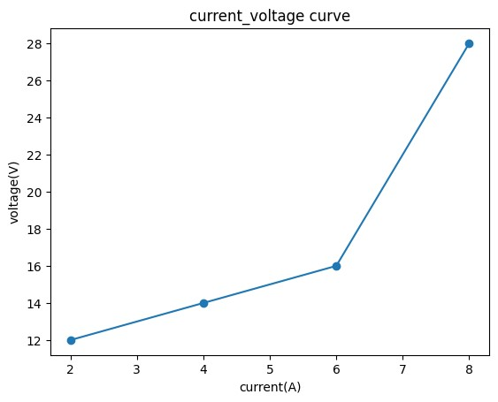



**[ 20000. 540000.]**

**CONCLUSION:**

**The PV panel model successfully demonstrates the impact of varying solar irradiance and temperature on the electrical performance of the solar module. By adjusting inputs such as solar irradiance, temperature, panel area, and efficiency, the model generates corresponding I-V (current-voltage) and P-V (power-voltage) characteristics**.